
Submitted by : Spogmai jan
Roll no : 2430 - 0081
Course : AI lab
Date of submission : 28/02/2026
Submitted to : MAM WARDAH

Assignment no : 03
Task 01:
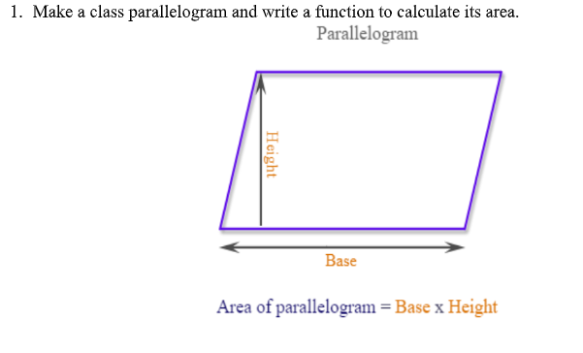

Code & output :




